1977 D
For the system 2 SO₂(g) + O₂(g) ↔ 2 SO₃(g) , ΔH is negative for the production of SO₃. Assume that one has an equilibrium mixture of these substances. Predict the effect of each of the following changes on the value of the equilibrium constant and on the number of moles of SO₃ present in the mixture at equilibrium. Briefly account for each of your predictions. (Assume that in each case all other factors remain constant.)
(a) Decreasing the volume of the system.
(b) Adding oxygen to the equilibrium mixture.
(c) Raising the temperature of the system.
Answer:
(a) As volume decreases, pressure increases and the reaction shifts in the direction of fewer molecules (less volume; more SO₃) to relieve the stress. Value of K_{eq} does not change.
(b) Additional O₂ disturbs the equilibrium and SO₃ is formed to relieve the stress. Value of K_{eq} does not change.
(c) Increase in temperature shifts the reaction to the left to “use up” some of the added heat. Less SO₃ remains. Value of K_{eq} decreases due to the relative greater increase in the rate of the endothermic reaction (reaction to the left).

1980 D
NH₄Cl(s) ↔ NH₃(g) + HCl(g) ΔH = +42.1 kilocalories
Suppose the substances in the reaction above are at equilibrium at 600K in volume V and at pressure P. State whether the partial pressure of NH₃(g) will have increased, decreased, or remained the same when equilibrium is reestablished after each of the following disturbances of the original system. Some solid NH₄Cl remains in the flask at all times. Justify each answer with a one-or-two sentence explanation.
(a) A small quantity of NH₄Cl is added.
(b) The temperature of the system is increased.
(c) The volume of the system is increased.
(d) A quantity of gaseous HCl is added.
(e) A quantity of gaseous NH₃ is added.
Answer:
(a) P_{NH3} does not change. Since NH₄Cl(s) has constant concentration (a = 1), equilibrium does not shift.
(b) P_{NH3} increases. Since the reaction is endothermic, increasing the temperature shifts the equilibrium to the right and more NH₃ is present.
(c) P_{NH3} does not change. As V increases, some solid NH₄Cl decomposes to produce more NH₃. But as the volume increases, P_{NH3} remains constant due to the additional decomposition.
(d) P_{NH3} decreases. Some NH₃ reacts with the added HCl to relieve the stress from the HCl addition.
(e) P_{NH3} increases. Some of the added NH₃ reacts with HCl to relieve the stress, but only a part of the added NH₃ reacts, so P_{NH3} increases.

1981 A
Ammonium hydrogen sulfide is a crystalline solid that decomposes as follows:
NH₄HS(s) ↔ NH₃(g) + H₂S(g)
(a) Some solid NH₄HS is placed in an evacuated vessel at 25ºC. After equilibrium is attained, the total pressure inside the vessel is found to be 0.659 atmosphere. Some solid NH₄HS remains in the vessel at equilibrium. For this decomposition, write the expression for K_{P} and calculate its numerical value at 25ºC.
(b) Some extra NH₃ gas is injected into the vessel containing the sample described in part (a). When equilibrium is reestablished at 25ºC, the partial pressure of NH₃ in the vessel is twice the partial pressure of H₂S. Calculate the numerical value of the partial pressure of NH₃ and the partial pressure of H₂S in the vessel after the NH₃ has been added and the equilibrium has been reestablished.
(c) In a different experiment, NH₃ gas and H₂S gas are introduced into an empty 1.00 liter vessel at 25ºC. The initial partial pressure of each gas is 0.500 atmospheres. Calculate the number of moles of solid NH₄HS that is present when equilibrium is established.
Answer:
(a) K_{P} = (P_{NH3})(P_{H2S})
P_{NH3} = P_{H2S} = 0.659/2 atm = 0.330 atm
K_{P} = (0.330)² = 0.109
(b) P_{NH3} = 2 P_{H2S}
(2x)(x) = 0.109 ; x = 0.233 atm = P_{H2S}
P_{NH3} = 0.466 atm
(c) Equilibrium pressures of NH₃ and H₂S are each 0.330 atm. Amounts of each NH₃ and H₂S that have reacted correspond to (0.500 - 0.330) = 0.170 atm.
n = mol of each reactant = mol of solid product
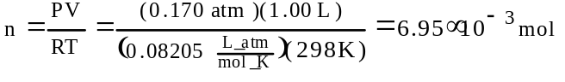

1983 A
Sulfuryl chloride, SO₂Cl₂, is a highly reactive gaseous compound. When heated, it decomposes as follows: SO₂Cl_{2(g)} → SO₂(g) + Cl₂(g). This decomposition is endothermic. A sample of 3.509 grams of SO₂Cl₂ is placed in an evacuated 1.00 litre bulb and the temperature is raised to 375K.
(a) What would be the pressure in atmospheres in the bulb if no dissociation of the SO₂Cl_{2(g)} occurred?
(b) When the system has come to equilibrium at 375K, the total pressure in the bulb is found to be 1.43 atmospheres. Calculate the partial pressures of SO₂, Cl₂, and SO₂Cl₂ at equilibrium at 375K.
(c) Give the expression for the equilibrium constant (either K_{p} or K_{c}) for the decomposition of SO₂Cl_{2(g)} at 375K. Calculate the value of the equilibrium constant you have given, and specify its units.
(d) If the temperature were raised to 500K, what effect would this have on the equilibrium constant? Explain briefly.
Answer:
(a)
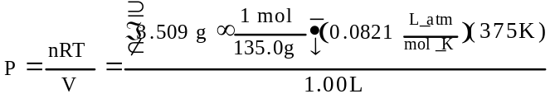
= 0.800 atm
(b) P_{SO2Cl2} = (0.800 - y) atm
P_{SO2} = P_{Cl2} = y atm
P_{T} = P_{SO2Cl2} + P_{SO2} + P_{Cl2}
1.43 atm = (0.800 - y + y + y) atm
y = 0.63 atm = P_{SO2} = P_{Cl2}
P_{SO2Cl2} = (0.800 - 0.63) atm = 0.17 atm
(c) 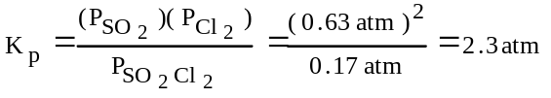
(d) Heat is absorbed during the dissociation and so K₅₀₀ > K₃₇₅. A stress is place on the system and K increases, which reduces the stress associated with the higher temperature.

1985 A
At 25ºC the solubility product constant, K_{sp}, for strontium sulfate, SrSO₄, is 7.6×10⁻⁷. The solubility product constant for strontium fluoride, SrF₂, is 7.9×10⁻¹⁰.
(a) What is the molar solubility of SrSO₄ in pure water at 25ºC?
(b) What is the molar solubility of SrF₂ in pure water at 25ºC?
(c) An aqueous solution of Sr(NO₃)₂ is added slowly to 1.0 litre of a well-stirred solution containing 0.020 mole F⁻ and 0.10 mole SO₄²⁻ at 25ºC. (You may assume that the added Sr(NO₃)₂ solution does not materially affect the total volume of the system.)
1. Which salt precipitates first?
2. What is the concentration of strontium ion, Sr²⁺, in the solution when the first precipitate begins to form?
(d) As more Sr(NO₃)₂ is added to the mixture in (c) a second precipitate begins to form. At that stage, what percent of the anion of the first precipitate remains in solution?
Answer:
(a) SrSO₄(s) ↔ Sr²⁺(aq) + SO₄²⁻(aq)
At equilibrium: [Sr²⁺] = X M = [SO₄²⁻]
X² = K_{sp} = 7.6×10⁻⁷
X = 8.7×10⁻⁴ mol/L, solubility of SrSO₄
(b) SrF₂(s) ↔ Sr²⁺(aq) + 2 F⁻(aq)
At equilibrium: [Sr²⁺] = X M = [F⁻] = 2X M
K_{SP} = [Sr²⁺][F⁻]² = (X)(2X)² = 7.9×10⁻¹⁰
X = 5.8×10⁻⁴ mol/L, solubility of SrF₂
(c) Solve for [Sr²⁺] required for precipitation of each salt.
K_{sp} = [Sr²⁺][F⁻]² = 7.9×10⁻¹⁰
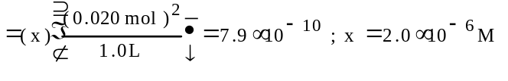
K_{sp} = [Sr²⁺][SO₄²⁻] = 7.6×10⁻⁷
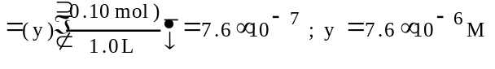
Since 2.0×10⁻⁶ M < 7.6×10⁻⁶ M, SrF₂ must precipitate first.
When SrF₂ precipitates, [Sr²⁺] = 2.0×10⁻⁶ M
(d) The second precipitate to form is SrSO₄, which appears when [Sr²⁺] = 7.6×10⁻⁶ M (based on calculations in Part c.)
When [Sr²⁺] = 7.6×10⁻⁶ M, [F⁻] is determined as follows:
K_{sp} = [Sr²⁺][F⁻]² = 7.9×10⁻¹⁰
= (7.6×10⁻⁶)(z)² = 7.9×10⁻¹⁰ ; z = 1.0×10⁻² M
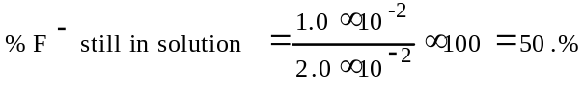

1988 A
At elevated temperatures, SbCl₅ gas decomposes into SbCl₃ gas and Cl₂ gas as shown by the following equation: SbCl₅(g) ↔ SbCl₃(g) + Cl₂(g)
(a) An 89.7 gram sample of SbCl₅ (molecular weight 299.0) is placed in an evacuated 15.0 litre container at 182ºC.
1. What is the concentration in moles per litre of SbCl₅ in the container before any decomposition occurs?
2. What is the pressure in atmospheres of SbCl₅ in the container before any decomposition occurs?
(b) If the SbCl₅ is 29.2 percent decomposed when equilibrium is established at 182ºC, calculate the value for either equilibrium constant K_{p} or K_{c}, for this decomposition reaction. Indicated whether you are calculating K_{p} or K_{c}.
(c) In order to produce some SbCl₅, a 1.00 mole sample of SbCl₃ is first placed in an empty 2.00 litre container maintained at a temperature different from 182ºC. At this temperature, K_{c}, equals 0.117. How many moles of Cl₂ must be added to this container to reduce the number of moles of SbCl₃ to 0.700 mole at equilibrium?
Answer:
(a) (1) 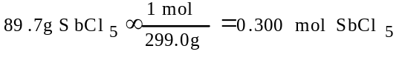
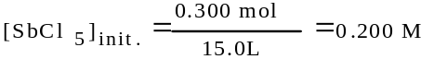
(2) T = 182ºC + 273 = 455K
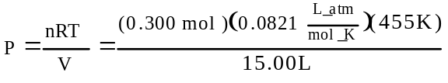
= 0.747 atm
OR
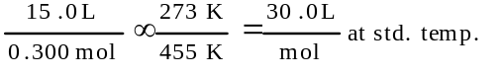
1 atm × f(22.4 L/mol,30.0 L/mol) = 0.747 atm
(b) [SbCl₃] = [Cl₂] = (0.0200 mol/L)(0.292)
= 5.84×10⁻³M
[SbCl₅] = (0.0200 mol/L)(0.708) = 1.42×10⁻²M
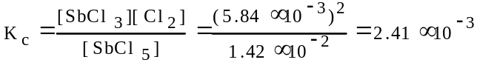
OR
P_{SbCl3} = P_{Cl2} = (0.747 atm)(0.292) = 0.218 atm
P_{SbCl5}= (0.747 atm)(0.708) = 0.529 atm
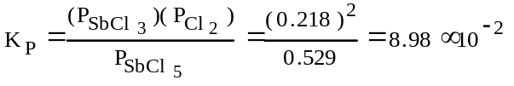
(c) 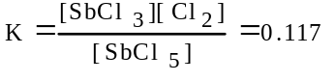
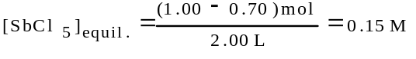
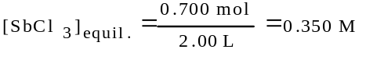
[Cl₂]_{equil.} = X M
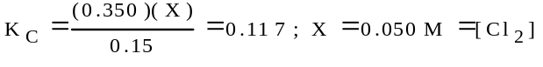
Moles Cl_{2(equil.)} = (0.0050 mol/L)(2.00L)
= 0.10 mol Cl₂
Moles Cl₂ needed to make 0.300 mol SbCl₃ into SbCl₅ = 0.30 mol
Moles Cl₂ that must be added = 0.40 mol

1988 D
NH₄HS(s) ↔ NH₃(g) + H₂S(g) ΔHº = +93 kilojoules
The equilibrium above is established by placing solid NH₄HS in an evacuated container at 25ºC. At equilibrium, some solid NH₄HS remains in the container. Predict and explain each of the following.
(a) The effect on the equilibrium partial pressure of NH₃ gas when additional solid NH₄HS is introduced into the container
(b) The effect on the equilibrium partial pressure of NH₃ gas when additional solid H₂S is introduced into the container
(c) The effect on the mass of solid NH₄HS present when the volume of the container is decreased
(d) The effect on the mass of solid NH₄HS present when the temperature is increased.
Answer:
(a) The equilibrium pressure of NH₃ gas would be unaffected. K_{P} = (P_{NH3})(P_{H2S}). Thus the amount of solid NH₄HS present does not affect the equilibrium.
(b) The equilibrium pressure of NH₃ gas would decrease. In order for the pressure equilibrium constant, K_{P}, to remain constant, the equilibrium pressure of NH₃ must decrease when the pressure of H₂S is increased. K_{P} = (P_{NH3})(P_{H2S}). (A complete explanation based on LeChatelierÆs principle is also acceptable.)
(c) The mass of NH₄HS increases. A decrease in volume causes the pressure of each gas to increase. To maintain the value of the pressure equilibrium constant, K_{p}, the pressure of each of the gases must decrease. The decrease is realized by the formation of more solid NH₄HS. K_{p} = (P_{NH3})(P_{H2S}). (A complete explanation based on LeChatelier’s principle is also acceptable.)
(d) The mass of NH₄HS decreases because the endothermic reaction absorbs heat and goes nearer to completion (to the right) as the temperature increases.

1992 A
2 NaHCO₃(s) ↔ Na₂CO₃(s) + H₂O(g) + CO₂(g)
Solid sodium hydrogen carbonate, NaHCO₃, decomposes on heating according to the equation above.
(a) A sample of 100. grams of solid NaHCO₃ was placed in a previously evacuated rigid 5.00-liter container and heated to 160ºC. Some of the original solid remained and the total pressure in the container was 7.76 atmospheres when equilibrium was reached. Calculate the number of moles of H₂O(g) present at equilibrium.
(b) How many grams of the original solid remain in the container under the conditions described in (a)?
(c) Write the equilibrium expression for the equilibrium constant, K_{P}, and calculate its value for the reaction under the conditions in (a).
(d) If 110. grams of solid NaHCO₃ had been placed in the 5.00-liter container and heated to 160ºC, what would the total pressure have been at equilibrium? Explain.
Answer:
(a) 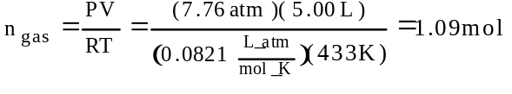
mol H₂O = (¹/₂)(1.09 mol) = 0.545 mol H₂O(g)
(b)
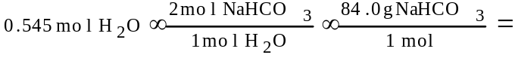
= 91.9 g NaHCO₃ decomposed
remaining = 100.g - 91.6g = 8.4g
OR
100 -
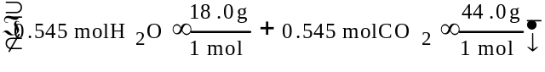
= 100g - 33.8g = 66g (or 66.2g) [includes Na₂CO₃ solid in this mass]
(c) K_{p} = (P_{H2O})(P_{CO2}) =(3.88)(3.88)atm² = 15.1 atm²
(d) Pressure would remain at 7.76 atm. Since some solid remained when 100.g was used (and there has been no temperature change), then using 110g will not affect the equilibrium.

1994 A
MgF₂(s) ↔ Mg²⁺(aq) + 2 F⁻(aq)
In a saturated solution of MgF₂ at 18ºC, the concentration of Mg²⁺ is 1.21×10⁻³ molar. The equilibrium is represented by the equation above.
(a) Write the expression for the solubility-product constant, K_{sp}, and calculate its value at 18ºC.
(b) Calculate the equilibrium concentration of Mg²⁺ in 1.000 liter of saturated MgF₂ solution at 18ºC to which 0.100 mole of solid KF has been added. The KF dissolves completely. Assume the volume change is negligible.
(c) Predict whether a precipitate of MgF₂ will form when 100.0 milliliters of a 3.00×10⁻³-molar Mg(NO₃)₂ solution is mixed with 200.0 milliliters of a 2.00×l0⁻³-molar NaF solution at 18ºC. Calculations to support your prediction must be shown.
(d) At 27ºC the concentration of Mg²⁺ in a saturated solution of MgF₂ is 1.17×10⁻³ molar. Is the dissolving of MgF₂ in water an endothermic or an exothermic process? Give an explanation to support your conclusion.
Answer:
(a) K_{sp} = [Mg²⁺][F⁻]² = (1.21×10⁻³)(2.42×10⁻³)²
= 7.09×10⁻⁹
(b) X = concentration loss by Mg²⁺ ion
2X = concentration loss by F⁻ ion
[Mg²⁺] = (1.21×10⁻³ - X) M
[F⁻] = (0.100 + 2.42×10⁻³ - 2X) M
since X is a small number then (0.100 + 2.42×10⁻³ - 2X) ≈ 0.100
K_{sp} = 7.09×10⁻⁹ = (1.21×10⁻³ - X)(0.100)²
X = 1.2092914×10⁻³
[Mg²⁺]= 1.21×10⁻³-1.20929×10⁻³ = 7.09×10⁻⁷M
(c) [Mg²⁺] = 3.00×10⁻³M × 100.0 mL/300.0 mL = 1.00×10⁻³M
[F⁻] = 2.00×10⁻³ M × 200.0 mL/300.0 mL = 1.33×10⁻³ M
trial K_{sp} = (1.00×10⁻³)(1.33×10⁻³)² = 1.78×10⁻⁹
trial K_{sp} < = 7.09×10⁻⁹, ∴ no ppt.
(d) @ 18ºC, 1.21×10⁻³ M MgF₂ dissolves
@ 27ºC, 1.17×10⁻³ M MgF₂ dissolves
MgF₂ ↔ Mg²⁺ + 2 F⁻ + heat
dissolving is exothermic; if heat is increased it forces the equilibrium to shift left (according to LeChatelier’s Principle) and less MgF₂ will dissolve.

1995 A
CO₂(g) + H₂(g) ↔ H₂O(g) + CO(g)
When H₂(g) is mixed with CO₂(g) at 2,000 K, equilibrium is achieved according to the equation above. In one experiment, the following equilibrium concentrations were measured.
[H₂] = 0.20 mol/L
[CO₂] = 0.30 mol/L
[H₂O] = [CO] = 0.55 mol/L
(a) What is the mole fraction of CO(g) in the equilibrium mixture?
(b) Using the equilibrium concentrations given above, calculate the value of K_{c}, the equilibrium constant for the reaction.
(c) Determine K_{p} in terms of K_{c} for this system.
(d) When the system is cooled from 2,000 K to a lower temperature, 30.0 percent of the CO(g) is converted back to CO₂(g). Calculate the value of K_{c} at this lower temperature.
(e) In a different experiment, 0.50 mole of H₂(g) is mixed with 0.50 mole of CO₂(g) in a 3.0-liter reaction vessel at 2,000 K. Calculate the equilibrium concentration, in moles per liter, of CO(g) at this temperature.
Answer:
(a) CO = f(0.55 mol, 1.6 mol) = 0.34
(b) K_{c} = ([H₂O][CO])/([H₂][CO₂]) = (0.55×0.55)/(0.20×0.30) = 5.04
(c) since Δn = 0, K_{c} = K_{p}
(d) [CO] = 0.55 - 30.0% = 0.55 - 0.165 = 0.385 M
[H₂O] = 0.55 - 0.165 = 0.385 M
[H₂] = 0.20 + 0.165 = 0.365 M
[CO₂] = 0.30 + 0.165 = 0.465 M
K = (0.385)²/(0.365×0.465) = 0.87
(e) let X = Δ[H₂] to reach equilibrium
[H₂] = 0.50 mol/3.0L - X = 0.167 - X
[CO₂] = 0.50 mol/3.0L - X = 0.167 - X
[CO] = +X ; [H₂O] = +X
K = X²/(0.167 - X)² = 5.04 ; X = [CO] = 0.12 M

1998 D
C(s) + H₂O(g) ↔ CO(g) + H₂(g) ΔHº = +131kJ
A rigid container holds a mixture of graphite pellets (C(s)), H₂O(g), CO(g), and H₂(g) at equilibrium. State whether the number of moles of CO(g) in the container will increase, decrease, or remain the same after each of the following disturbances is applied to the original mixture. For each case, assume that all other variables remain constant except for the given disturbance. Explain each answer with a short statement.
(a) Additional H₂(g) is added to the equilibrium mixture at constant volume.
(b) The temperature of the equilibrium mixture is increased at constant volume.
(c) The volume of the container is decreased at constant temperature.
(d) The graphite pellets are pulverized.
Answer
(a) CO will decrease. An increase of hydrogen gas molecule will increase the rate of the reverse reaction which consumes CO. A LeChatelier Principle shift to the left.
(b) CO will increase. Since the forward reaction is endothermic (a ΔH > 0) an increase in temperature will cause the forward reaction to increase its rate and produce more CO. A LeChatelier Principle shift to the right.
(c) CO will decrease. A decrease in volume will result in an increase in pressure, the equilibrium will shift to the side with fewer gas molecules to decrease the pressure, ∴, a shift to the left.
(d) CO will remain the same. Once at equilibrium, the size of the solid will affect neither the reaction rates nor the equilibrium nor the concentrations of reactants or products.

